Q 35
include<stdio.h>
int searchInsert(int* nums, int numsSize, int target) {
int low =0;
int high = numsSize -1;
int mid;
while(low <=high) {
mid = low+(high -low)/2;
if(nums[mid] == target) {
return mid;
} else if(nums[mid] < target) {
low =mid +1;
}else {
high = mid -1;
}
}
return low;
} 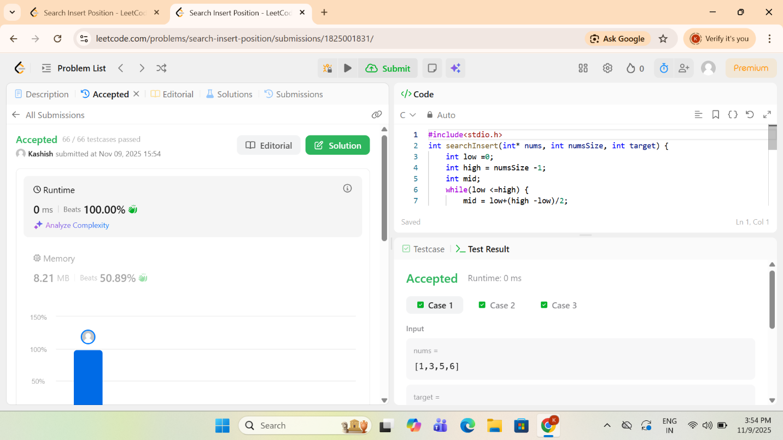

Q 136 single number
int result =0;
for(int i =0; i< numsSize; i++) {
result ^=nums[i];
}
return result ;

}

